Setting up Windows Server
Steps to set up windows server

Step 1. Create the Virtual Machine

Open Hypervisor
Create → New Virtual Machine
Configure VM
Vm -name win-server-01
OS Type:
Microsoft Windows
Windows Server 2022 (64-bit)
Assign resources:
· CPU: 2–4 vCPUs
· RAM: 8 GB
· Disk: 80 GB (dynamic allocation recommended)
NAT → internet access only
Attach Installation Media
Mount:
Iso
-> finish

Step 2. Boot and Start Installation
Power on Vm
At Windows setup:
- Select language
- Select keyboard layout
- Click:
Install Now

3. Select Installation Edition
You'll likely see options similar to:
- Windows Server Standard Evaluation
- Windows Server Standard Evaluation (Desktop Experience)
- Windows Server Datacenter Evaluation
- Windows Server Datacenter Evaluation (Desktop Experience)
For easier administration choose:
Windows Server Standard Evaluation (Desktop Experience)

4. Configure disk
Select:
Custom: Install Windows only
Choose the VM disk:
Drive 0 Un allocated Space
Click:
Next
Allow setup to complete.
The VM may restart several times.

5. First Login Configuration
Create an Administrator password.
Recommended:
Minimum 12–16 characters
Uppercase + lowercase + numbers + symbols

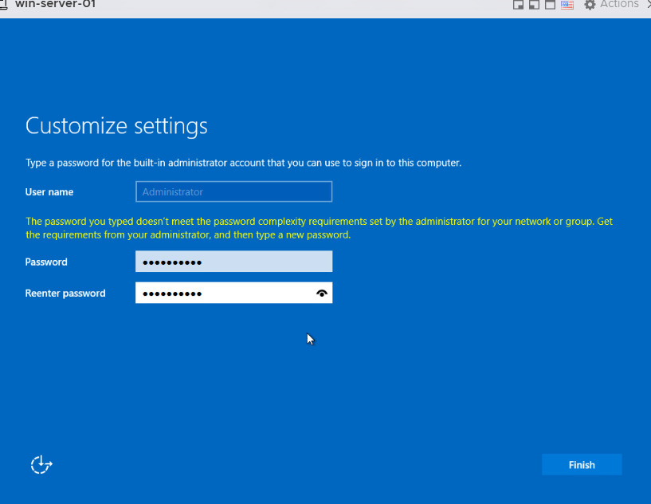

6. Rename Server
Open:
Server Manager
→ Local Server
→ Computer Name
→ Change
Example:
WIN-SRV-01
Restart.

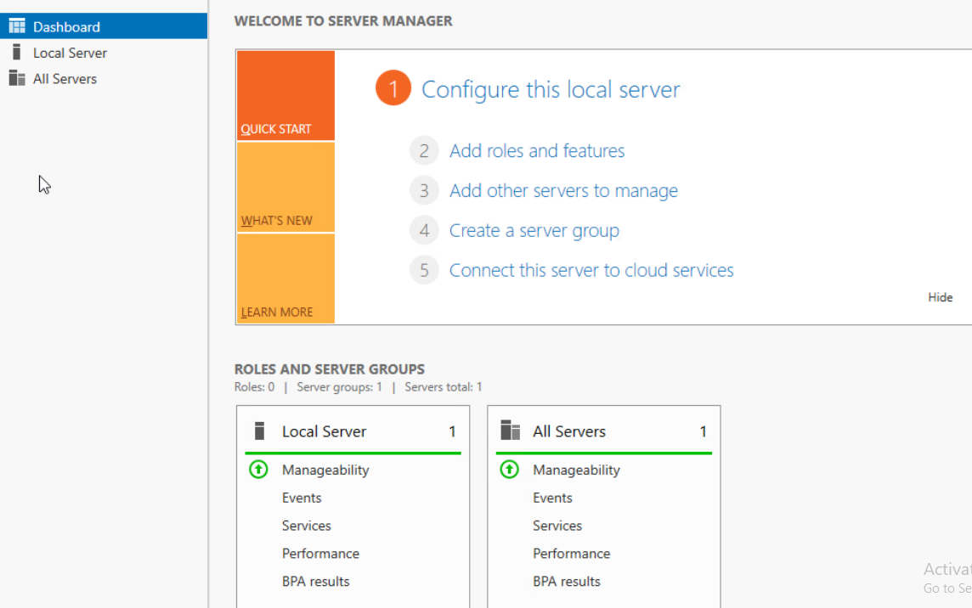

7. Configure Network
Set a static IP:
Server Manager
→ Local Server
→ Ethernet
→ IPv4
Example:
IP Address: 192.168.1.10
Subnet: 255.255.255.0
Gateway: 192.168.1.1
DNS: 8.8.8.8
Verify:
ipconfig
ping google.com

8. Install Updates
Open:
Settings
→ Windows Update
Install all available updates.
Restart.

Configure Remote Access
Enable Remote Desktop:
Server Manager
→ Local Server
→ Remote Desktop
→ Enable
Allow firewall rules.
Test:
mstsc
Connect using:
IP address or server name

